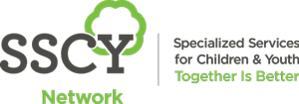

Specialized Services for Children and Youth invites you to join us for
Breakfast at SSCY, our monthly learning series!

Topic: Is Research a Four-letter word? Practical Advice for Rehabilitation Clinicians
This talk will focus on the critical role that rehabilitation clinicians at the forefront of care can play in closing gaps between research and practice. Attendees will leave armed with practical take-away strategies for action and inspiration in their settings and lives.
Presented by: Dr. K. Sibley, PhD
When: 8:00 -9:00 am, Tuesday, November 10th, 2020; Via Zoom

Mark your calendar for our upcoming sessions:
8-9am December 08th, 2020: Maternal/fetal health

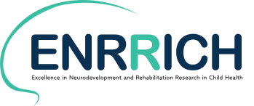
Everyone is welcome to attend!

