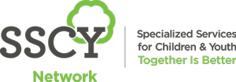

Specialized Services for Children and Youth invites you to join us for
Breakfast at SSCY, our monthly learning series!

Topic: Disrupting the Intergenerational Transmission of Mental Illness & Developmental Inequities
One in five children under the age of 5 have a mother with a mental illness (MI) resulting in a 4-fold elevated risk for the child’s own mental and behavioral health difficulties. The early emergence of child MI is linked to development impairments as well as health-risk behaviors, suicidality, and low quality of life. Despite these risks, there are limited interventions that address maternal MI while simultaneously promoting child mental health and development. The BRIDGE “Building Regulation in Dual Generations,” hosted at SCCY 2019-2020, was designed to address these needs by bringing together a transdiagnostic maternal MI treatment with best practices in prevention-based parenting principles designed to improve child mental health and build resilience from future health impairments. This presentation will discuss year 1 pilot results as well as next steps in group-based, telehealth and mobile health options for addressing maternal-child mental health needs.
Sandra Hunter will present her plans to investigate and document traditional child rearing practices from Indigenous communities in Manitoba, eventually working toward First Nation created parenting programs.
In this session you will learn:
- How to understand the links between maternal mental illness and children’s health and developmental needs
- To identify opportunities for SSCY families to participate in research on family mental health and inform the development of future programs.
Presented by: Dr. Leslie Roos, PhD, C. Psych; Co-presenter: Sandra Hunter
When: 8:00 -9:00 am, Tuesday, October 13, 2020; virtually via Go-to-Webinar
Mark your calendar for our upcoming sessions:
November 10th, 2020: Knowledge Translation for Clinicians
Presented by: Dr. K. Sibley

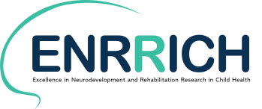
Everyone is welcome to attend!

